**newTable** steps:

1. Make sure all routine files for the table compiled successfully after the latest change done to source.

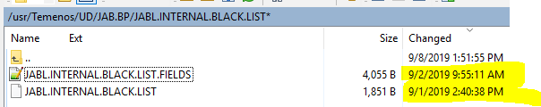

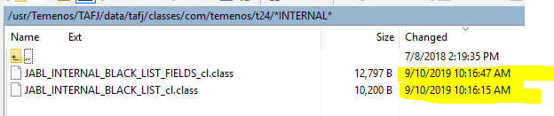

1. Call the command “**newTable”** with the name of the table



1. You can do other things while it simulates a T24 session, when it ends you will see the green END line, and command input at current working directory given back to user

